ROSSMOYNE SHS SEMESTER 1, 2009
UNIT 2C MATHEMATICS EXAMINATION

SECTION A NON-CALCULATOR SECTION

STUDENT’S NAME _____________________________________

TEACHER:-
(Circle one name) KNOBLAUCH LONGLEY SUTTON TAY

TIME ALLOWED FOR THIS PAPER
Reading time before commencing Section A Five minutes
Working time for Section A (non calculator) Forty minutes
Changeover time between Sections A and B Five minutes
Reading time before commencing Section B Five minutes
Working time for Section B Eighty minutes
Available marks for Section A: 40 marks
Available marks for Section B: 80 marks

MATERIAL REQUIRED / RECOMMENDED FOR THIS PAPER
TO BE PROVIDED BY THE SCHOOL:
This Question/Answer booklet
TO BE PROVIDED BY THE CANDIDATE
Standard Items Pens, pencils, eraser, ruler
Special items Curriculum Council Mathematical Formulae and Statistics Tables Book, drawing instruments, templates, notes on two sheets (4 sides) of A4 paper and calculators (Section B only) satisfying the conditions set by the Curriculum Council.

NOTE: Personal copies of the Tables Book should not contain any handwritten notes, symbols, signs, formulae or any other marks (including underlining and highlighting), except the name and address of the candidate, and may be inspected during the examination.

IMPORTANT NOTE TO CANDIDATES

No other items may be taken into the examination room.
It is your responsibility to ensure that you do not have any unauthorised notes or other items of a non-personal nature in the examination room. If you have any unauthorised material with you, hand it to the supervisor BEFORE reading any further.

STRUCTURE OF THIS PAPER

This paper consists of two sections:
Section A is a non-calculator section – no calculator may be used in this section.
Time allowed for this section is 40 minutes. At the end of 40 minutes, this section will be collected by the supervisor. There will be a 5 minute changeover before commencing Section B.
Section B is a section where approved calculators are permitted. Time allowed for this section is 80 minutes. At the end of 80 minutes, this section will also be collected by the supervisor.

INSTRUCTIONS TO CANDIDATES
ALL questions should be attempted. You may answer the questions in any order you wish.
Write answers in the spaces provided. Extra pages are supplied at the back of this booklet. If the extra pages are used, label the questions clearly. Indicate on the original question that your working continues at the end of this booklet.

Show all working clearly, in sufficient detail to allow your answers to be checked readily and for marks to be awarded for reasoning. Incorrect answers given without supporting reasoning cannot be allocated any marks. If you repeat an answer to any question, ensure that you cancel the answers you do not wish to have marked.
SECTION A
NO CALCULATORS PERMITTED FOR THIS SECTION
TIME 40 minutes
AVAILABLE MARKS 40 marks
- [ 6 marks]
Round each as required
- Express 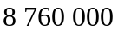 in scientific notation
[1]

- Use division to find whether or not the decimal equivalent of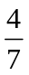 terminates or recurs
[1]

- Round each as required

  - 35.82 to 1 decimal place [1]

  - 8.764 to two significant figures [1]

- Evaluate, giving your answer in scientific form

  - 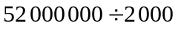 [1]

  - 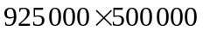 [1]

- [ 4 marks]
Fill in the missing numbers in the tables below and determine whether linear, quadratic or neither (Give reasons)

x | 1 | 2 | 3 | 4 | 5 | 6 | 7 | 8 | 9 | 10
y | 15 | 19 | 19 | 15 | 7 | -5 | -21
[2]

x | 1 | 2 | 3 | 4 | 5 | 6 | 7 | 8 | 9
y | 7 | 2 | -3 | -8 | -13 | -18
[2]

- [ 8 marks]
For each of the lines shown below, write down (where possible)

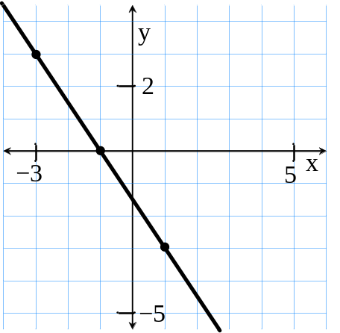

a) the coordinates of where the graph
crosses the x-axis

(b) the coordinates of where the graph
crosses the y-axis

(c) the gradient of the line

(d) the equation of the line

[4]

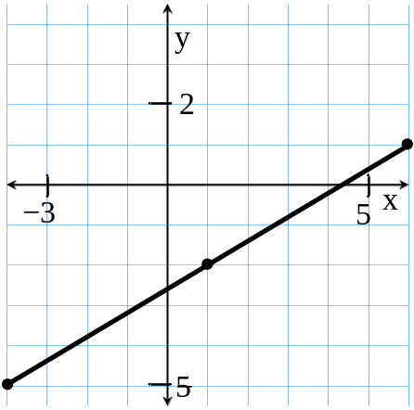

a) the coordinates of where the graph
crosses the x-axis

(b) the coordinates of where the graph
crosses the y-axis

(c) the gradient of the line

(d) the equation of the line

[4]

- [ 6 marks]
Solve algebraically, showing your working
- 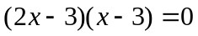
[2]

- 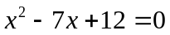
[2]

- 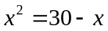
[2]

- [ 4 marks]
In a survey concerning modes of transportation, interviewees were asked whether they went to work by car or whether they used public transport. The numbers responding in various ways to the questions are shown in the appropriate sections in the Venn diagram and in the table below.
Complete both the Venn diagram and the table.

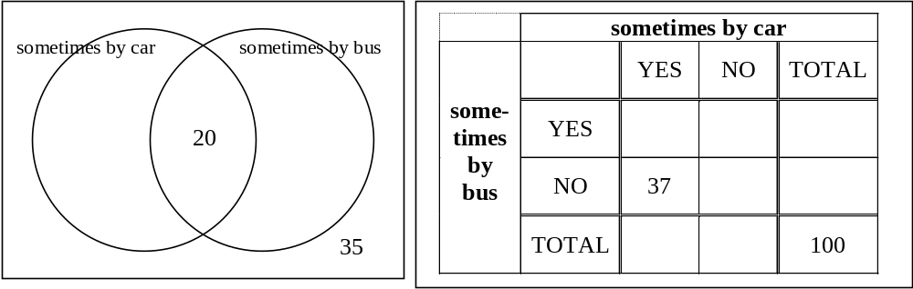
[4]
- [ 4 marks]
The universal set, U and the two sets, A and B contained within it are such that :
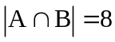 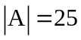 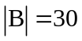 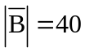
Find

- 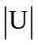
[1]

- 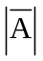
[1]

- 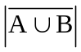
[1]

- 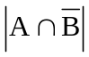
[1]

- [ 4 marks]
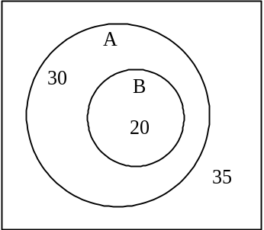
Using the information in the accompanying Venn diagram, determine the following

- 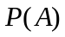
[1]

- 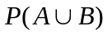
[1]

- 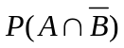
[1]

- 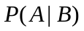
[1]

- [ 4 marks]
Use Prim’s algorithm to determine the minimum spanning tree for the network described in the following table and use your results to show the tree in the network below

 | A | B | C | D | E | F | G
A |  | 20 |  |  | 25 |  | 30
B | 20 |  | 30 |  | 15
C |  | 30 |  | 15 |  | 15
D |  |  | 15 |  |  | 10 | 20
E | 25 | 15 |  |  |  | 15 | 40
F |  |  | 15 | 10 | 15
G | 30 |  |  | 20 | 40
[2]

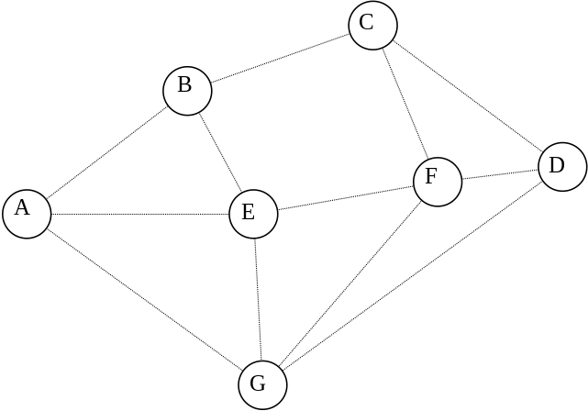
[2]

